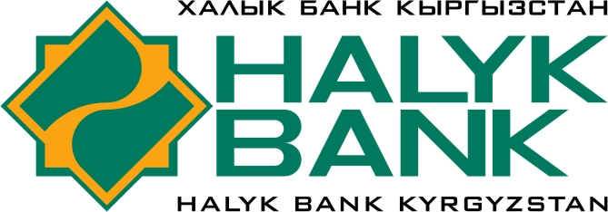

ОТКРЫТОЕ АКЦИОНЕРНОЕ ОБЩЕСТВО «ХАЛЫК БАНК КЫРГЫЗСТАН»

Кыргызская Республика, г. Бишкек, 720033, ул. Фрунзе, 390

БИК 125001, к/с 1013810000500189 в НБКР, ИНН 01204199910016, SWIFT МAKA KG 22, ОКПО 22192566

СПИСОК КОРРЕСПОНДЕНТСКИХ СЧЕТОВ по состоянию на 15 сентября 2021 года

Реквизиты для клиентов ОАО «Халык Банк Кыргызстан» для зачисления ЕВРО:
CURRENCY | :56A INTERMEDIARY BANK: | :57A BENEFICIARY BANK | :59 BENEFICIARY: | :70 DETAILS OF PAYMENT:
 |  |  |  | Размер поля ограничен 140 символами
 | ING Belgium NV/SA, Brussels, Belgium  SWIFT: BBRUBEBB | Account: 301-0179125-47-EUR  Sberbank PAO  19, Vavilov str.  Moscow, 117997, Russia  SWIFT: SABRRUMM | Account: 30111978300000000279  Halyk Bank Kyrgyzstan OJSC, Bishkek, Kyrgyz Republic  SWIFT: MAKAKG22 | In favor of Beneficiary name and address,  to account №:, purpose of payment (for  what ,invoice #, contract #, date)  Наименование и адрес получателя,
EUR
номер счета и назначение платежа (за
что, номер инвойса, контракта, дата)
EUR | Landesbank Baden-Württemberg  Am Hauptbahnhof 2  D-70173 Stuttgart  SWIFT: SOLADEST | Account: 2808994  Halyk Bank Kyrgyzstan OJSC, Bishkek, Kyrgyz Republic  SWIFT: MAKAKG22 | Наименование и адрес получателя, номер счета  Beneficiary name, account number, address | Purpose of payment (for  what ,invoice #, contract #, date)  Назначение платежа (за  что, номер инвойса, контракта, дата)
EUR | Raiffeisen Bank International AG  Am Stadtpark 9, 1030 Vienna, Austria  SWIFT: RZBAATWW | Account: 00150092584  Joint Stock Company «ALFA-BANK»,  27 Kalanchevskaya str., Moscow, 107078, Russia  SWIFT: ALFARUMM | Account: 30111978700000000084  Halyk Bank Kyrgyzstan OJSC, Bishkek, Kyrgyz Republic  SWIFT: MAKAKG22 | In favor of Beneficiary name and address,  to account №:, purpose of payment (for  what ,invoice #, contract #, date)  Наименование и адрес получателя,
EUR | VTB Bank (Deutschland) AG, | Account: 0102758018  VTB Bank PAO,  43, Vorontsovskaya str., building  1, Moscow, 109147, Russia  SWIFT: VTBRRUMM | Account: 30111978155550000102  Halyk Bank Kyrgyzstan OJSC, Bishkek, Kyrgyz Republic  SWIFT: MAKAKG22 | In favor of Beneficiary name and address,  to account №:, purpose of payment (for  what ,invoice #, contract #, date)  Наименование и адрес получателя,
 | Frankfurt am Main, Germany,
 | SWIFT: OWHBDEFF
номер счета и назначение платежа (за
что, номер инвойса, контракта, дата)

